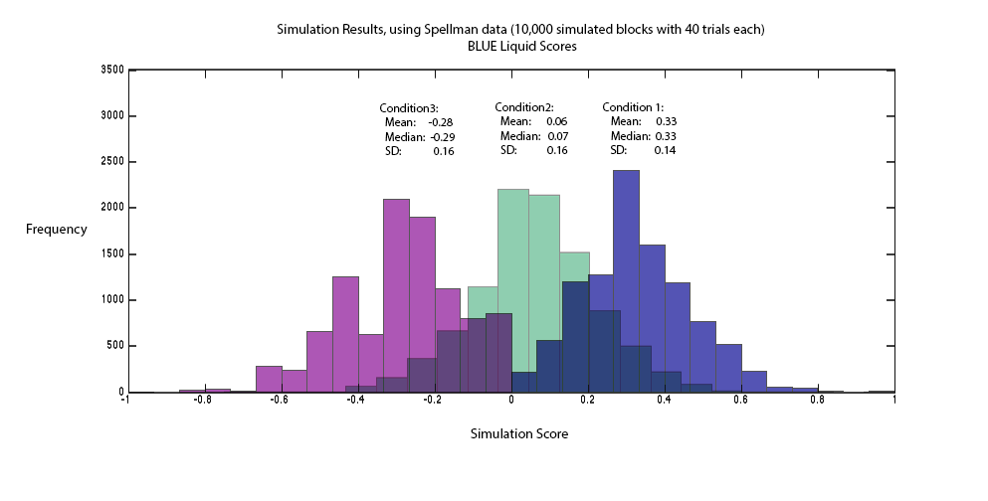

Frequency

Simulation Results. using Spellman data (10,000 simulated blocks with 40 trials each)

Simulation Score